FREQUENCY SPECTRUM MANAGEMENT PANEL (FSMP)

Eleventh Working Group meeting

Web Meeting, 1 – 12 March 2021

Agenda Item 3: Radio Altimeter and Wireless Aircraft Intra-Communications (WAIC) issues

Information Paper: Study of Interference with Radio Altimeters from Potential 5G Implementations in the United States

(Presented by ICCAIA)

SUMMARY
Regulatory actions by countries are enabling the introduction of 5G cellular services in frequency bands near the 4 200 - 4 400 MHz band, raising concerns about potential interference to radio altimeters. For example, recent regulatory activity in the United States has allowed 5G to be used in the frequency band 3 700 - 3 980 MHz. This new usage led RTCA, Inc. to conduct a study to determine the extent and severity of any potential risk to public safety from harmful interference to radio altimeters. Subsequent to the RTCA study, aviation industry stakeholders developed recommendations for 5G mitigations that could be used by 5G systems until new radio altimeter standards can be developed, and equipment compliant with those standards developed and deployed. This information paper presents the findings of the RTCA study and subsequent efforts to develop recommended 5G mitigations.

- INTRODUCTION
  - International regulatory actions by multiple administrations are enabling the introduction of 5G cellular systems into frequency bands near 4 200 - 4 400 MHz. The aviation industry has raised concerns about potential interference with radio altimeters (“RAs”) because existing RAs were developed to comply with standards that were developed when existing services in adjacent frequency bands did not present a risk for harmful interference. In the United States, 5G cellular systems are permitted to operate in the 3 700 - 3 980 MHz band (“C-band”). This led RTCA, Inc. to conduct a study working with aviation and wireless industry stakeholders to determine the extent and severity of any potential risk to aircraft equipped with RAs. The study was completed with inputs from the aviation industry and 5G technical parameters supplied by the wireless industry to provide a detailed technical report (“RTCA Report”) confirming the risk of harmful interference to RAs. The RTCA effort was followed by a collaboration of aviation stakeholders to develop recommendations for mitigations that can be implemented to maintain safe operation of aircraft while enabling 5G deployment in the C-band.
  - Unfortunately, mitigations proposed by the aviation industry have not been adopted by any country. As a result, ICCAIA has concerns with the potential impact to public and aviation safety, especially given the long time it takes to develop new standards and and deploy compliant equipment to make radio altimeters resilient to terrestrial signals.
  - RTCA, Inc. Special Committee 239 and EUROCAE Working Group 119 formed a joint committee that is reconsidering current minimum operational performance standards (MOPS) for RAs that accounts for emerging technologies that could impact radio altimeter performance. It is expected that new MOPS will need to work in concert with ICAO SARPS development to ensure the continued safe international operation of RA-equipped aircraft.
- DISCUSSION
  - Background
The continued and accelerating global growth in demand for wireless telecommunications services has led to an increasing pressure to allocate more radio frequency spectrum for use by cellular/IMT services. This, in turn, has created concerns about the impact on aviation and public safety due to this new usage.

    - FSMP Job Cards – Developments in the ITU-R seeking additional spectrum for IMT culminated in resolutions at WRC-15 that indicated expanded use of mid-band spectrum for IMT services. Additionally, Resolution COM4/1 authorized the Aeronautical Mobile Route Service use of the 4 200 - 4 400 MHz band (“RA band”) for Wireless Avionics Intra-Communication (“WAIC”) Systems, subject to the establishment of WAIC SARPs in the ICAO Convention. These proposed changes to frequency spectrum in and around the RA band raised concern in the FSMP that RA might experience harmful interference if service rules for new entrants in these bands were not constrained by existing international standards. To this end, the FSMP issued two related job cards, FSMP.006.01 - “Develop radio frequency and interference rejection characteristics for radio altimeters” and FSMP.007.01 – “Develop and maintain SARPs and guidance to prevent WAIC / Radio Altimeter interference,” in November 2016 to establish SARPs for RAs and WAIC systems intended to prevent harmful interference to RAs.,
Job card FSMP.006.01 provides the following problem statement:

Recent ITU activities have threatened aeronautical systems operating in the 4200-4400 MHz band by considering the introduction of mobile broadband systems in adjacent frequency bands. Existing ITU-R documentation, and related documentation such as RTCA DO-155 Minimum Performance Standard Airborne Low-Range Radar Altimeters, describe some performance characteristics for radio altimeters, however additional/refined details are necessary to enable a proper assessment of suitable protection requirements for systems operating on adjacent frequency bands. Without standardized frequency and interference performance characteristics, there is no way to specify suitable protection from interference from services operating in adjacent frequency bands. This creates safety risks to flying aircraft operating radio altimeters, especially noting that non-aeronautcial systems can now operate at the adjacent frequency bands.

The intent of this job card was to stimulate investigations to determine the susceptibility of RAs to interference from potential signals from bands adjacent to the RA band.

  - Multi-Stakeholder Studies

    - Estblishment of the Joint Committee – EUROCAE established Working Group 119 (“WG-119”) in February 2020 to updated RA MOPS to address robustness against the existing and planned future RF environments. Similarly, RTCA, Inc. established Special Committee 239 (“SC-239”) in April 2020. The committees joined efforts to establish a joint committee that would update existing RA MOPS.
    - RTCA MSG – Immediately after establishing SC-239, RTCA, Inc. filed a letter with the FCC inviting all stakeholders to join a multi-stakeholder group (“MSG”) as recommend in the Order. The goal of the RTCA MSG was to work with aviation and wireless industry technical personnel to “examine matters relevant to coexistence between anticipated 5G operators and other flexible use licensees in the 3700-3980 MHz band and incumbent safety-of-life radio altimeters in the 4000-4200 MHz band.” The RTCA MSG performed a detailed analysis of the risk of harmful interference to RAs based on service rules in the FCC Order, RA technical parameters provided by the aviation industry, and 5G parameters provided by the wireless industry.
  - The RTCA MSG Report
    - The RTCA MSG produced a report (“Report” or “RTCA Report”) in October 2020 that presented detailed analysis of the risk of harmful interference to commercial RAs operating in a range of realistic operational scenarios. The report is the only publicly available analysis of this risk that uses RA technical parameters provided by aviation industry subject matter experts and 5G technical parameters provided by wireless industry subject matter experts. The RTCA Report describes the potential impact of harmful interference to RAs on aircraft operations, the methodology used in both the analysis of 5G emissions and empirical determination of RA interference tolerance thresholds, and the aircraft operational scenarios considered in the analysis. It then presents the results of AVSI interference tolerance threshold testing and the RTCA MSG interference analysis. Finally, the RTCA Report presents the findings and conclusions of the study concerning the risk of harmful interference, without recommending any mitigations that might eliminate this risk.
    - Report Scope – The scope of the RTCA Report was specifically limited to a study of 5G telecommunications operations in the 3.7-3.98 GHz band, which may be encountered in the United States in accordance with the FCC Order. It did not consider potential 5G deployments being suggested in different parts of the world with potentially different technical characteristics. Furthermore, the intent was only to assess the risk of harmful interference and did not develop or recommend specific mitigations that may or may not be necessary.
    - Impact of Harmful Interference – The RTCA Report described the potential impact of harmful interference on RA-equipped aircraft including such consequences as loss of situational awareness, controlled flight into terrain, and loss of safety systems (TCAS/ACAS, PWS, and TAWS). RA failure modes and their associated operational impact and severity were summarized in Table 5-1, in which two of eleven identified failures were deemed Catastrophic.
    - Interference Analysis Methodology and Assumptions – The analysis was conducted in two steps: (1) a parametric interference model was developed for various operational scenarios to compute the expected received interference power at a victim RA and then (2) this power was compared to interference tolerance thresholds determined from empirical measurements of representative RAs. The basic model was described by the equation
$$P_{RX}=P_{source}+G_{source}-L_{prop}+G_{RA}-L_{RX}$$

2.3.5 Where the output power ($P_{source})$ and gain ($G_{source}$) of the 5G transmitter (base station and/or user equipment) are attenuated by the propagation from source to the RA receiving antenna ($L_{prop}$) for the scenario being analyzed. The interference power is referenced to the input of the RA unit ($P_{RX}$) by accounting for the RA antenna gain ($G_{RA}$) and aircraft cabling losses ($L_{RX}$).

2.3.6 A parameterized model was used to allow adjustment of 5G emitter source parameters from the assumed values obtained from publicly available sources to more accurate values based on information obtained from wireless industry subject matter experts. This allowed higher fidelity of the interference power analysis to conditions anticipated from new 5G operations in the 3 700 – 3 980 MHz band in a range of scenarios. Two scenarios based on actual aircraft operations and existing mobile wireless base station locations were also analyzed in the RTCA Report to provide a real-world context: (1) a fixed-wing aircraft conducting an instrument approach procedure, and (2) a medical evacuation helicopter landing at elevated heliports at urban hospitals. Additionally, the effect of multiple user equipment transmitters located both onboard a RA-equipped aircraft and below the aircraft in the field of view of the RA antenna were considered.

2.3.7 Interference analysis used the propagation model described in Recommendations ITU-R P.528. For interference scenarios considering downlink emissions from 5G base stations, the time availability is assumed to be 1% and 50% for uplink from user equipment (UE) on the ground. Modeling of 5G base station emission sources considered both Advanced Antenna Systems (AAS) and fixed-beam sectoral antennae patterns and technical parameters. Ground-based UE was simulated by a random distribution of indoor and outdoor emitters. While current regulation does not permit actively transmitting UE on board aircraft, there is no fail-safe means to prevent it. So interference from UE on board aircraft was analyzed by modeling a distribution of UE transmitting on board an RA-equipped aircraft with different levels of front-end coupling for different types of aircraft based on values from empirical studies.

2.3.8 Radio altimeters can be installed with different antenna that may have different performance characteristics when considering signals outside the frequency band for which they were designed. Thus a representative receive antenna pattern was measured for fundamental emissions in the frequency band 3 700 – 3 980 MHz. Furthermore, the aircraft operational envelope was considered for each analysis case to determine acceptable limits on pitch and roll angles.

2.3.9 Analysis resulted in a series of plots that characterize the level of 5G interference received by a victim RA as a function of both lateral distance between the source and RA and the aircraft height above ground level. An example is the plot for Usage Category 1 operations and an Urban 16 x 16 AAS base station at -30° vertical scan that was provided in Figure 10-1 of the RTCA Report and reproduced below.

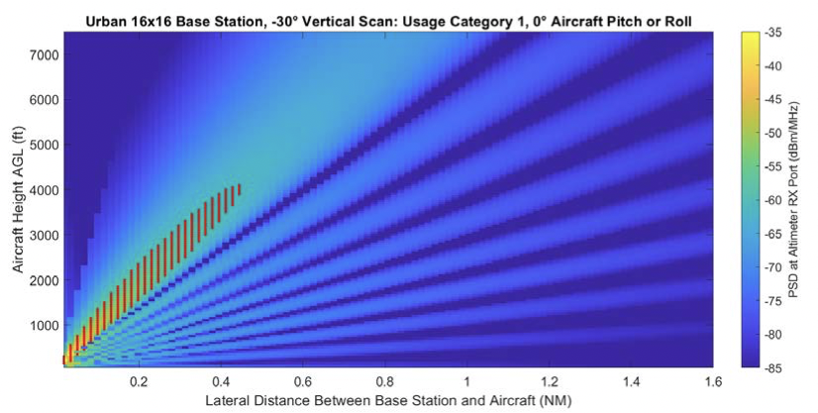
Figure 1: Urban 16 x 16 AAS BS at -30° Vertical Scan, Usage Category 1 (from Fig. 10-1 of RTCA Report)

Similar plots were produced for the variety of 5G base station antenna and Usage Categories considered in the report. The red hashes superimposed on the plot indicate signal levels that exceed the RA threshold tolerance.

2.3.10 RA Interference Tolerance Thresholds – The RTCA Report addresses the application of RA protection criteria established in Recommendation ITU-R M.2059 to C-band 5G interference before considering empirical interference tolerance thresholds measured by AVSI. The report presents interference tolerance threshold as a function of altitude considering both RF energy falling in the RA band and fundamental emissions outside the RA band. AVSI used black-box testing that made no use of proprietary receiver design information for any of the RA models tested. Thus, identification of specific interference mechanisms was outside the scope of the study and direct evaluation of protection criteria for the specific models tested was not possible.
2.3.11 AVSI performed tests on nine different commercial altimeter models. All altimeters were production units that were fit for installation in certified aircraft and thus met minimum operational performance specifications (MOPS) required by certifying authorities. The models selected for testing included both FMCW and pulsed altimeters and represented a range of applications and capabilities, from triple redundant installations on commercial passenger aircraft capable of autolanding in difficult environmental conditions, to helicopter and general aviation aircraft. Thus, in order to accommodate performance differences exhibited by models designed for these different applications, the test results were aggregated into three Usage Categories defined as follows:

- Usage Category 1, covering commercial air transport airplanes, both single-aisle and wide-body;
- Usage Category 2, covering all other fixed-wing aircraft not included in Usage Category 1, including regional, business aviation, and general aviation airplanes; and
- Usage Category 3, covering both transport and general aviation helicopters.

2.3.12 The altimeters that were allocated to these Usage Categories are summarized in Table 7-1 of the RTCA Report. Aggregate Interference Tolerance Threshold Masks (“ITMs”) were produced for each category and these were compared to computed 5G interference powers for scenarios applicable to each category. This approach allowed all altimeters of a particular class to be analyzed at the same time to determine the worst-case interference conditions all RAs in a category.

2.3.13 The general approach used in AVSI testing was to simulate operating conditions of each radio altimeter under test, and then systematically injecting increasing levels of representative 5G interference (5G NR Frequency Range 1 test model 1.1) into the altimeter receiver until the altitude output is affected to an unacceptable extent. The existing operation conditions consist of, at a minimum, an altitude return signal with an amplitude corresponding to the loop loss standards given in the MOPS for the test altitude being considered. This is done using one or more optical fiber delay lines along with fixed and variable RF attenuators. Further, for any altimeter models which may be used in dual or triple installations on a single aircraft, the interference from radio altimeters co-located on a single aircraft is represented using one or two voltage-controlled oscillators (“VCOs”) to generate FMCW interference waveforms with sweep characteristics and power levels determined based on the transmission and installation parameters of the altimeter under test. Finally, for tests considering low altitude (200 feet in this case) operations at an airport, fourteen additional VCOs are used to model the FMCW interference from the radio altimeters installed in other aircraft on the ground, with power levels determined based on an assumed scenario geometry derived from ICAO aerodrome design guidelines and referred to as the Worst-Case Landing Scenario (“WCLS”). The test case that were considered were summarized in Table 7-3 of the RTCA Report as reproduced below.

Table 1: Interference Tolerance Threshold Test Cases (from Table 7-3 of RTCA Report)
Usage Category | Own-Ship VCO Configuration | Low Altitude  (200 feet) | Medium Altitude (1,000 feet) | High Altitude (Variable)
1 | Large fixed-wing | WCLS | No off-board VCOs | No off-board VCOs
2 | Small/medium fixed-wing | WCLS | No off-board VCOs | No off-board VCOs
3 | Helicopter | WCLS | No off-board VCOs | No off-board VCOs
 |  | No off-board VCOs

2.3.14 Aggregated measurements were interpolated to produce ITMs. As an example, the worst-case measured 5G fundamental emissions (centered at 3750 MHz) interference tolerance thresholds for Usage Category 1, along with the interpolated ITMs, was shown in Figure 9-1 of the RTCA Report and is reproduced below.

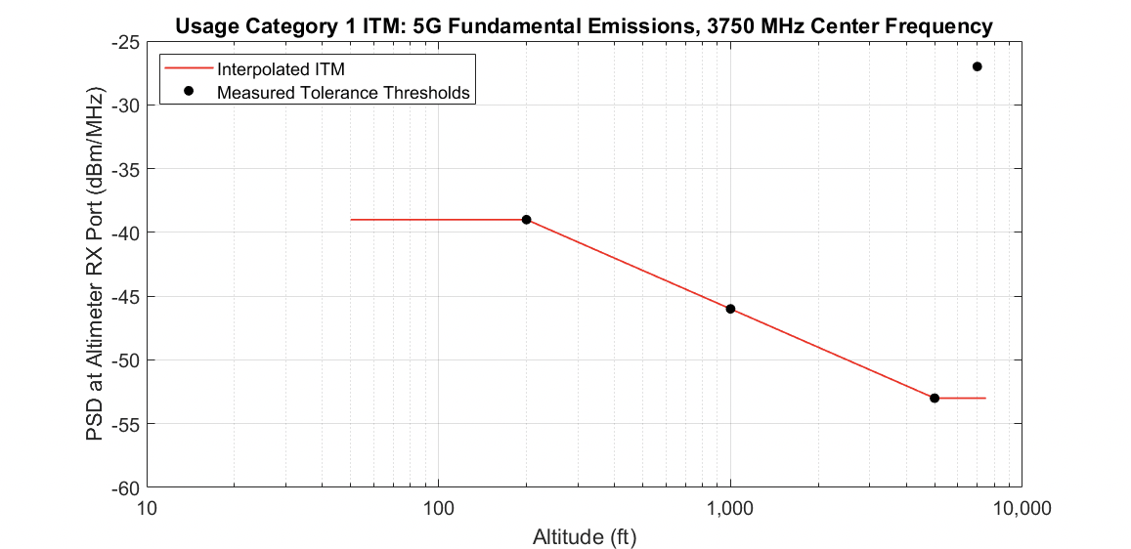
Figure 2: Usage Category 1 ITM for 5G Fundamental Emissions at 3750 MHz (from Fig. 9-1 of RTCA Report)

Similar curves were produced for the range of 5G center frequencies and RA Usage Categories.

2.3.15 RTCA Report Findings – Finally, for each Usage Category, a summary plot was generated that provided a comparison of the computed 5G interference level with the empirically determined ITMs. An example of such a plot is provided in Figure 10-3 of the RTCA Report and reproduced below.

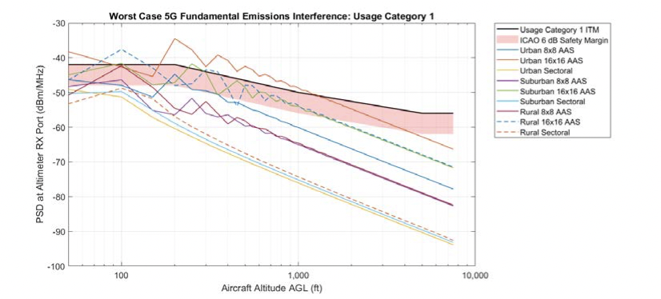
Figure 3: Maximum 5G Fundamental Emissions Levels, Usage Category 1 (from Fig. 10-3 of RTCA Report)

2.3.16 The RTCA Report concludes that

The results presented in this report reveal a major risk of harmful interference to radar altimeters on all types of civil and commercial aircraft caused by 5G telecommunications systems in the 3.7–3.98 GHz band in a broad range of operational scenarios. This risk is widespread and has the potential for broad impacts to aviation operations in the United States, including the possibility of Catastrophic failures leading to multiple fatalities. Further, this risk cannot be adequately mitigated by the aviation industry acting alone.

2.4 5G Mitigations – A letter filed with the FCC by the Aviation Community in December 2020 proposed certain mitigations as the appropriate basis for serving the public interest in aviation safety.

The letter plotted Interference Tolerance Thresholds introduced in the RTCA Report in terms of power spectral flux density (“PSFD”) rather than PSD used in the RTCA Report in order to specify flexible use emission limits in terms that removes the dependence on specific emitter-RA geometries used in the RTCA study. The intent was to maximize the solution space available to the wireless industry for implementing mitigations that will prevent harmful interference to RAs.

2.4.1 The letter recommends a set of mitigations:
- 5G power spectral flux density levels should not exceed radio altimeter interference threshold limits.
- Reduce 5G base station conducted spurious emissions limits into the radio frequency band 4200-4400 MHz to -48 dBm/MHz.
- Limit effective isotropic radiated power (“EIRP”) total power of User Equipment (“UE”) operating while on board aircraft to -16 dBm.
- Reduce 5G UE conducted spurious emissions limits across the 4200-4400 MHz band to -30 dBm/MHz for UEs operating on the ground and -57 dBm/MHz for UEs on board aircraft.

Additionally, the letter recommends that RAs deployed on helicopters require additional consideration since they operate at low-altitude and potentially in very close proximity to 5G base stations.

2.4.2 The scope of the RTCA MSG Report was limited to deployment of C-band 5G in the United States and used technical parameters relevant to this case. The risk of harmful interference in other planned 5G deployments must be considered based on the technical parameters relevant for each country. However, the RTCA MSG Report provides a useful reference for administrations to consider the impacts of reallocating existing spectrum for 5G cellular services prior to defining service rules for such deployments. At a minimum, aviation regulators and spectrum regulators can use the information in the RTCA Report as a baseline for cooperative planning of a safe introduction of new 5G cellular operations.

- CONCLUSION
Changes to the frequency spectrum use in the vicinity of the radio frequency band 4 200 – 4 400 MHz presents a risk of harmful interference to existing radio altimeter-equipped aircraft operating in the United States.
The aviation industry and aviation regulators must continue to monitor and share information on 5G deployment in the C-band and engage with governments to encourage protection of public safety and radio altimeter systems.
As part of this engagement, share the RTCA Report with regulators considering 5G deployment in the C-band.
ICAO should leverage the work of RTCA and EUROCAE to develop SARPS as directed by job card FSMP.006.01.
— END —

FCC, “Expanding Flexible Use of the 3.7-4.2 GHz Band,” Report and Order and Order of Proposed Modification, 35 FCC Rcd 2343 (2020). Available from: https://docs.fcc.gov/public/attachments/FCC-20-22A1.pdf.
RTCA, “Assessment of C-Band Mobile Telecommunications Interference on Low Range Radar Altimeter Operations,” RTCA Paper No. 258-20/SC239-006 (rel. Sept. 18, 2020). Available from: https://www.rtca.org/wp-content/uploads/2020/10/SC-239-5G-Interference-Assessment-Report_274-20-PMC-2073_accepted_changes.pdf
See Letter from Aviation Community to Marlene Dortch, FCC, GN Docket No. 18-122 (filed Dec. 7, 2020). Available from: https://ecfsapi.fcc.gov/file/12072836329004/20201207-Aviation%20and%20Aerospace%20Suggested%20C-Band%205G%20Mitigations%20GN%2018-122-Filed%20Version.pdf.
See for example Resolution 154 and Resolution 223 in ITU-R, “Final Acts WRC-15, World Radiocommunication Conference,” Geneva 2015. Available from: https://www.itu.int/dms_pub/itu-r/opb/act/R-ACT-WRC.12-2015-PDF-E.pdf.
Id.
ICAO FSMP, “Develop radio frequency and interference rejection characteristics for radio altimeters,” Job Card FSMP.006.01, November 2016. Available from: https://www.icao.int/safety/FSMP/Documents/Job%20Cards.
ICAO FSMP, “Develop and maintain SARPs and guidance to prevent WAIC / Radio Altimeter interference,” Job Card FSMP.007.01, November 2016. Available from: https://www.icao.int/safety/FSMP/Documents/Job%20Cards.
See Letter from Terry McVenes to Marlene Dortch, FCC, Notice of Multi-Stakeholder Group Meeting, GN Docket No. 18-122 (filed Apr. 20, 2020). Available from: https://ecfsapi.fcc.gov/file/104202099224796/FCC%20Register%20Letter%20MSG%20Start%20Up%2020-04-17%20Submitted.pdf.
Id.
RTCA Report at 88.
The Aviation Community consists of the Aerospace Industries Association (“AIA”), Aerospace Vehicle Systems Institute (“AVSI”), Air Line Pilots Association International, Aircraft Owners & Pilots Association (“AOPA”), Airlines For America, Inc (“A4A”), .Aviation Spectrum Resources, Inc., Garmin International, Inc., General Aviation Manufacturers Association, Helicopter Association International, Honeywell International Inc., International Air Transport Association, National Air Carrier Association and Regional Airline Association.
See Letter from the Aviaiton Community to Marlene Dortch, FCC, Proposed Mitigations for Flexible Use Licenses to Protect Existing Aeronautical Radar Altimeters, GN Docket No. 18-122 (filed Dec. 7, 2020). Available from: https://ecfsapi.fcc.gov/file/12072836329004/20201207-Aviation%20and%20Aerospace%20Suggested%20C-Band%205G%20Mitigations%20GN%2018-122-Filed%20Version.pdf.

